PSAT Results Information/Interpretation: 2019-20
JUNIORS – REMIND ACCOUNT: Sign-up for Mr. Smith’s Remind Account for current Newfane HS Juniors (class of 2021). Important information (this year and next) will be disseminated via Remind, such as important upcoming events, scholarship availability/deadlines, college deadlines, testing (SAT/ACT) registration updates/reminders, etc. Share with your parents!
College Board PSAT Results Interpretation Video (2:36 min.) and Khan Academy Video (50 sec.):
* https://collegereadiness.collegeboard.org/psat-nmsqt-psat-10/scores/understanding-scores
Better “You Tube” PSAT Score Interpretation Video from 3 years ago (7:48 min.):
*https://www.youtube.com/watch?v=KNQGjsOQGpU {or other new video: https://www.youtube.com/watch?v=1Skl8Q96EbI }
College Board info./links regarding scores: https://collegereadiness.collegeboard.org/psat-nmsqt-psat-10/scores
1. Go to studentscores.collegeboard.org (to sign up for a College Board account - save log-in info. for later use!)
2. If you don’t already have an account, you can create one by selecting “Sign Up” then enter the required information on the next page. Only the information marked with an asterisk (*) is required.
Make sure you keep this account log-in/password in a safe place since you will be needing it soon to register for the SAT Exam, and again to review your SAT (and AP) scores, and possibly to request scores to be sent to a college.
3. If you already have a College Board account (and you probably do not since you did not need to register for the PSAT Exam online), you can sign in with your username and password and click “Sign In” to be taken to your scores.
Sometime around Dec. 10-12, students should be able to view their PSAT scores on the College Board website.
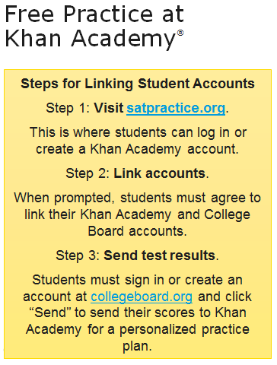
Students who did NOT take the PSAT Exam can still use the Khan Academy Free Practice tools. The only difference is that they will not have an individualized instruction plan in place since there are no PSAT Exam scores to link. All students can, and should, use the Khan Academy Practice Tools to prepare for the upcoming SAT Exam (May 2, 2020- at Newfane – register online at: www.collegeboard.org by April 3). It will also help with ACT test takers since tests are very similar now. Students must register themselves online for any SAT or ACT exams (links to both websites on guidance office webpage). Students who have free or reduced lunch can get a fee waiver for SAT and/or ACT exam registration- see Mr. Smith. It is recommended that you take the ACT Exam AND SAT Exam- then repeat the one you did better on and felt more comfortable with (“superscoring”).
College Board Opportunity Scholarships Available! Do what is required and possibly be drawn for one of many scholarships.
As a whole, how did our juniors do at this point in time? Not bad! Still some work to do in order to be ready for the SAT.
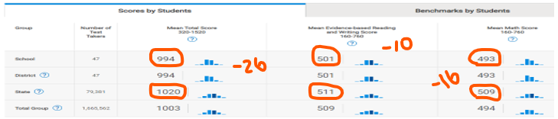

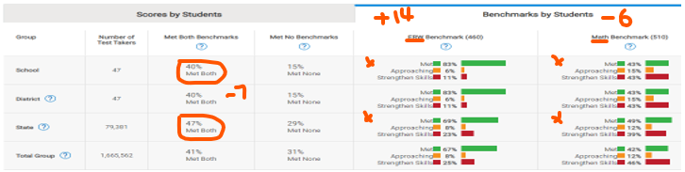

Differences Between PSAT and SAT:
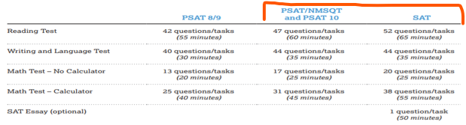
To compare SAT scores to ACT scores:
